Identifying Translationally Active Microbes from Environmental Samples

# Purpose and objectives

## Purpose

The purpose of the procedure is to utilize the ubiquitous “hunger” of microorganisms for L-methionine, an amino acid necessary for the synthesis of proteins. In this protocol we will use a surrogate or non-canonical amino acid with an azide or alkyne functional group that will allow us to tag newly synthesized proteins in cells.

## Objective

Bioorthagonal non-canonical amino acid tagging (BONCAT) is a relatively new tool that can be paired with flow cytometry (FCM), fluorescence activated sorting (FACS), and genetic assays like Fluorescence In Situ Hybridization (FISH) to identify microorganisms from environmental samples that are actively synthesizing protein. It is advantageous because it is a relatively cheap assay that can be done in a short time frame. It is also not heavily impacted by complex organic or inorganic material that are often found in environmental samples. The objective is to use these powerful tools to be able to better our understanding of microbial activity in lakes, rivers, soils, and other environmental matrices.

# How it works

## Incubation of samples with methionine (Met) analogs

There are two possible substitutes (that are mentioned in the literature) that can be used that are a) found to be nontoxic to bacteria and b) have efficient uptake rates. These surrogates are L-azidohomoalanine (AHA) and L-homopropargylglycine (HPG). They can take the place of L-methionine in proteins with the added benefit of having either an azide (AHA) or alkyne (HPG) functional group attached to it which can be utilized to attach a fluorescent dye to the protein and “tag” it, hence amino acid tagging.

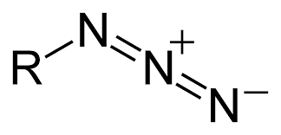

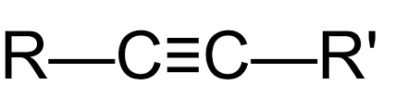

**Azide Functional**

**Group**

**Alkyne Functional**

**Group**

**L-azidohomoalanine**

**(AHA)**

**L-homopropargylglycine (HPG)**

**L-methionine**

## Click Chemistry

Following incubation with the surrogate amino acids, we can use click chemistry to expedite the cycloaddition reaction between the azide and alkyne functional group with a fluorescent dye. This tags the recently synthesized proteins, containing either AHA or HPG, which we can detect using flow cytometry or FACS. The dye needs to be a be an azide conjugate (for HPG) or an alkyne conjugate (for AHA) to bind and be detected. We have two ways make this reaction happen, Copper-catalyzed Azide-Alkyne Cycloaddition (CuAAC) and Strain-Promoted Azide-Alkyne cycloaddition (SPAAC).

CuAAC uses the Cu as a catalysis to expedite the cycloaddition reaction between azide and alkyne bonds. It is best performed in an aqueous solution, can be performed over a broad temperature range (0-160 °C), and has a strong resistance to pH (4-12).

**Chemical Reaction for CuAAC**

(Himo et al., 2005)

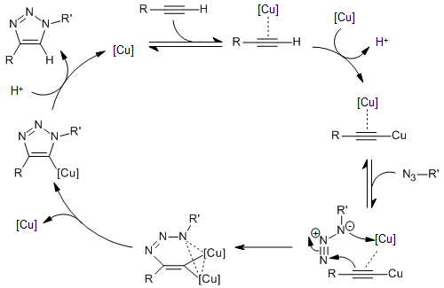

**Mechanisms for CuAAC**

(Worrell et al., 2013)

SPAAC uses the promiscuous nature of the cyclooctyne system to catalyze the same azide-alkyne reaction without the need for auxiliary chemicals to create a catalyst. This method does require an alkylating reagent to block free thiols and is limited to use with AHA. SPAAC is also has no apparent toxic traits and can be done under physiological conditions.

**Reaction for SPAAC**

(Yiming et al., 2022)

# Reagents and Materials

**Nanopure/MilliQ water**

Unless otherwise stated will be referred to as ultra-pure water and should be 0.2 mm filtered.

**L-azidohomoalanine (AHA)**

Stock solution made with 5 mg of AHA diluted with dimethlysulfoxide (DMSO) to 20 mM and stored between -5° C and -20° C.

**L-homopropargylglycine (HPG)**

Stock solution made with 5 mg of HPG diluted with dimethylsulfoxide (DMSO) to 20 mM and stored between -5° C and -20° C.

**4% Paraformaldehyde (PFA)**

0.2 mm filtered and stored at 4° C. This is used to fix samples that will undergo click chemistry.

**50% Glycerol**

Used to store samples for DNA assays and FACS

**Tris[(1-hydroxypropyl- 1H- 1,2,3-triazol-4-yl)methyl]amine (THPTA)**

50 mM in ultra-pure water and filter sterilized (0.2 mm). Store at -20° C.

Used in click chemistry to provide a substrate for surrogate.

**Phosphate buffered saline (PBS)**

Made in ultra-pure water and buffered to pH 7.4 before being filter sterilized (0.2 mm).

**Sodium Ascorbate (CuAAC only)**

Freshly made, 100 mM in 1x PBS. Make fresh and use the same day. This will act as a reducing agent to ensure that there is enough Cu (I) to catalyze the reaction.

**Copper Sulfate solution (CuSO4 X 5H2O) (CuAAC only)**

20 mM in ultra-pure water and filter sterilized (0.2 mm). Can be stored at room temperature or at 4° C. This will supply the Cu (I) catalyst needed for CuAAC.

**Aminoguanidine hydrochloride**

100 mM in 1x PBS and made fresh each time.

**Ethanol (EtOH)**

Make a 96% EtOH solution and use it the same day. We will dilute this to 50% and 80% EtOH later.

**Flourophore dyes**

These should be made in DMSO in a concentration range of 1-10 mM and prepared following the manufacturer's instructions

*I need to narrow down what concentration I want. I am thinking about doing a small range of concentrations*

**P-1000 pipette and tips**

**P-20 pipette and tips**

**2 mL microcentrifuge tubes**

Label with site ID and whether it is a Live (L) or a Kill (K).

# Procedure

## Incubation of sample with methionine surrogate

1. Using a p-1000, aliquot your sample into a 2 mL microcentrifuge tube
   1. For glycerol samples, pipette 1.19 mL of your sample
   2. For PFA-fixed samples, pipette 1.14 mL of your sample
2. Add the fixatives/preservatives
   1. Add 300 mL of 50% glycerol to each kill
   2. Add 371 mL of 4% PFA to each kill
3. Add your methionine analog to each live
   1. 12 mL for glycerol samples
   2. 15 mL for PFA samples
4. Incubate the samples
   1. Incubate lives at 20° C for 2 hours
   2. Incubate kills at 4° C for 2 hours (note, no substrate has been added to kills. This is just to ensure they are fixed)
5. Fix the lives and inoculate the kills
   1. Lives
      1. Add 300 mL of 50% glycerol to each live
      2. Add 371 mL of 4% PFA to each live
   2. Add methionine analog to each kill
      1. Add 12 mL for glycerol samples
      2. Add 15 mL for PFA samples
6. Perform second incubation
   1. The (now fixed) lives will incubate at 4° C
   2. The (now inoculated) kills will incubate at 20° C
7. Store samples at -80° C until click chemistry, FACS, or DNA assay

## Click Chemistry (PFA samples only)

1. Centrifuge to pellet biomass
   1. 14,000 xg for 15 minutes
   2. Remove the supernatant
2. Dehydrate and permeabilize cells
   1. Resuspend in 50% EtOH (dilute in tube with ultra-pure water) and vortex to mix
   2. Centrifuge at 14,000 xg for 5 min
   3. Repeat a and b with 80% and 96% EtOH
   4. Finally resuspend in 221 mL of 1x PBS (do not need to remove small volumes of EtOH because it does not interfere with the click chemistry)
3. Prepare dye premix
   1. 1.25 mL of CuSO4 solution
   2. 2.50 mL THPTA
   3. 0.30 mL dye
   4. Allow premix to react for 3 min @ RT in the dark
4. While premix is reacting
   1. Add sodium ascorbate (12.5 mL) to samples
   2. Add aminoguandidine hydrocholride (12.5 mL) to samples
5. Invert tubes and incubate
   1. 30 min @ RT in the dark
6. After incubation
   1. Wash 3 times with PBS
   2. 1 additional time with 50% EtOH
   3. Centrifuge between washes for 5 min at 14,000 xg
7. Resuspend in 1:1 mix of PBS:EtOH. Vortex to mix

*It ends here for now